**Name:** SIDDHI ARUN SUBHEDAR

**PRN:** 1262240621

**MIT- WPU (PGD AI ML)**

**#B Write a R program to create a sequence of number from 21 to 29**

CODE:

sequence=seq(from=21,to=29)

print(sequence)

ANSWER:

[1] 21 22 23 24 25 26 27 28 29

**#C Write a R program to extract the first 10 English letters in lower case and last 10 letters in**

CODE:

firstlower=letters[1:10]

print(firstlower)

firstupper=LETTERS[1:10]

print(firstupper)

between=LETTERS[23]

print(between)

ANSWER:

> print(firstlower)

[1] "a" "b" "c" "d" "e" "f" "g" "h" "i" "j"

> print(firstupper)

[1] "A" "B" "C" "D" "E" "F" "G" "H" "I" "J"

> print(between)

[1] "W"

**#A] Plot various graph scatter graph, line chart, scatter plot**

**regression line, bar plot, box plot**

library(dplyr)

data(mtcars)

summary(mtcars)

plot <- ggplot(data = mtcars, aes(x = hp, y = mpg, color = factor(cyl))) +

geom_point(size = 3) +

labs(title = "Miles per Gallon vs Horsepower",

x = "Horsepower",

y = "Miles per Gallon",

color = "Number of Cylinders") +

theme_minimal()

print(plot)

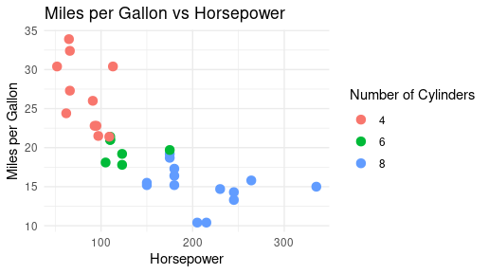

plot_smooth <- ggplot(data = mtcars, aes(x = hp, y = mpg, color = factor(cyl))) +

geom_point(size = 3) +

geom_smooth(method = "lm", se = FALSE, color = "blue") +

labs(title = "Miles per Gallon vs Horsepower with Linear Trend",

x = "Horsepower",

y = "Miles per Gallon",

color = "Number of Cylinders") +

theme_minimal()

print(plot_smooth)

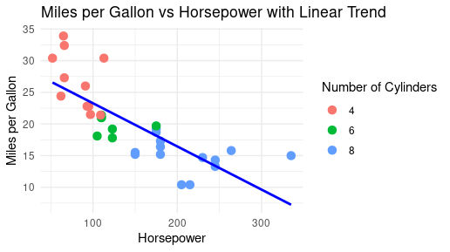

bar_plot <- ggplot(mtcars, aes(x = factor(gear))) +

geom_bar(fill = "skyblue") +

labs(title = "Distribution of Cars by Number of Gears",

x = "Number of Gears",

y = "Count") +

theme_minimal()

print(bar_plot)

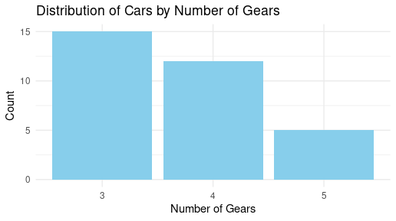

box_plot <- ggplot(mtcars, aes(x = factor(cyl), y = mpg, fill = factor(cyl))) +

geom_boxplot() +

labs(title = "Miles per Gallon by Number of Cylinders",

x = "Number of Cylinders",

y = "Miles per Gallon") +

theme_minimal()

print(box_plot)

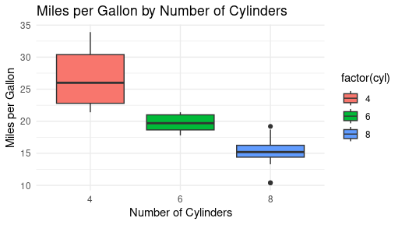

ggsave("scatter_plot.pdf", plot = plot, width = 6, height = 4)

ggsave("scatter_plot_smooth.pdf", plot = plot_smooth, width = 6, height = 4)

ggsave("bar_plot.pdf", plot = bar_plot, width = 6, height = 4)

ggsave("box_plot.pdf", plot = box_plot, width = 6, height = 4)